The Pocket Toiletry Case
From
Travel Pro Inc.

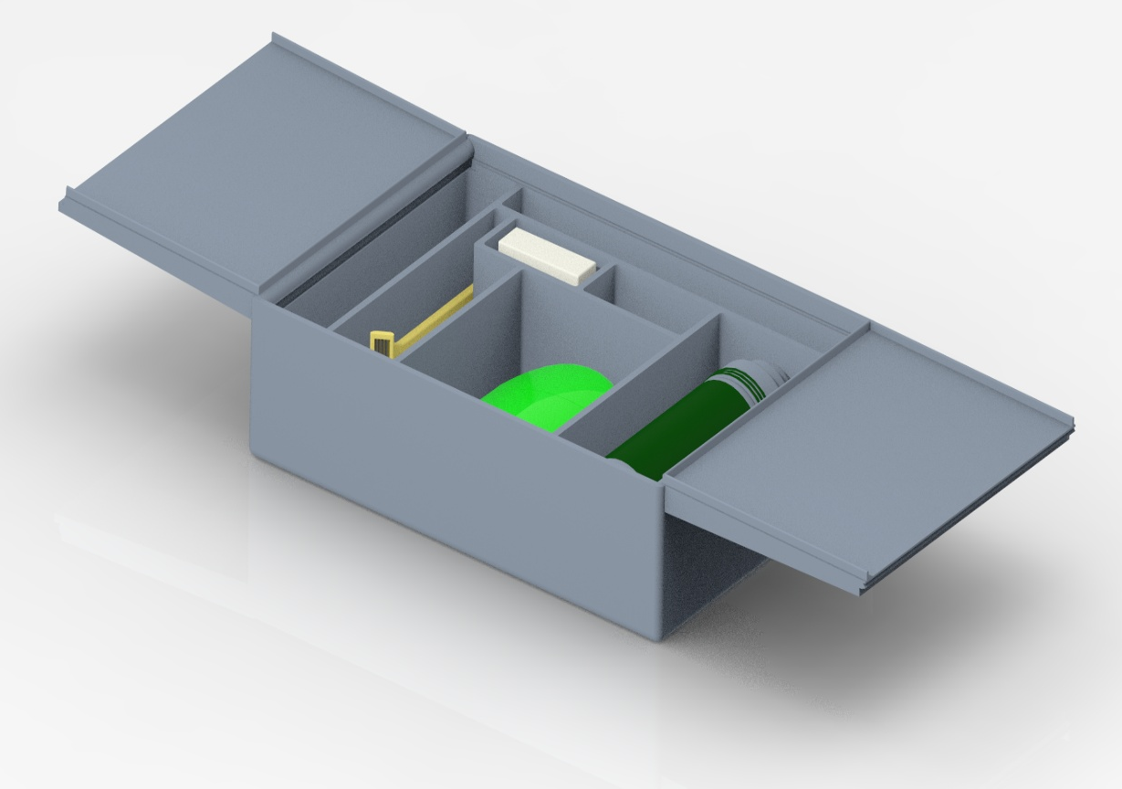

REFER TO THE FOLLOWING MANUAL FOR INFORMATION REGARDING FEATURES OF THE POCKET TOILETRY CASETM AND ITS FUNCTIONING CAPABILITIES
Travel Pro Inc’s
Pocket Toiletry Case
Table of Contents
Assembly................................................3
Initial Setup and Use................................4
Maintenance...............................................5
Safety Information....................................6
Warranty Information..................................7
Service Center..............................................8

Assembly
Travel Pro Inc. Pocket Toiletry Case consists of three (3) individual pieces manufactured and assembled in our warehouse for your convenience.
Disassembly will be needed to clean and properly maintain the product over a prolonged period. Our team has made assembly and disassembly extraordinarily simple. The image below indicates the product assembled with both lids properly placed on the hinges.

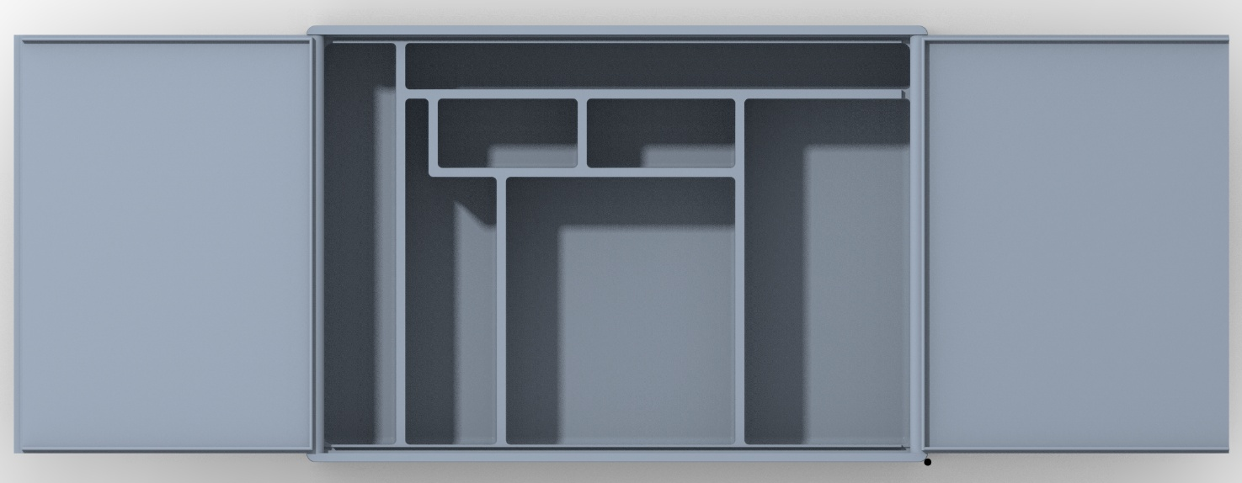
Every Pocket Toiletry Case comes with one (1) tray body and two (2) dual-purpose lids.

Initial Setup and Usage
Whether you buy your product online or in one of our partner stores, the Pocket Toiletry Case will be preassembled and ready for use. To access the Tray Body, consisting of seven (7) compartments of varying sizes to fit typical toiletry travel items, you will need to lift the left dual-purpose lid first using the indented surface of the lid. From there you may open the right dual-purpose lid to view and access the entirety of the contents contained within the Tray Body.
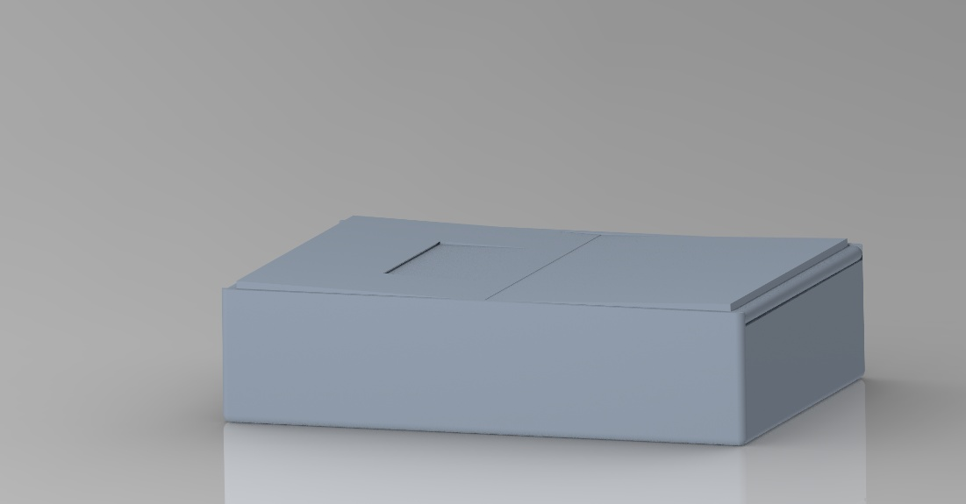
Both lids have been designed to click into the holes located at the top of the tray body, creating a hinge feature. By design, when the lid is opened and allowed to lay in outward position from the tray, it will sit on the lip of the tray body, hovering above the surface the case is sitting on. This feature creates a countertop stand which you can place your items on without worry of contamination by questionable surfaces.
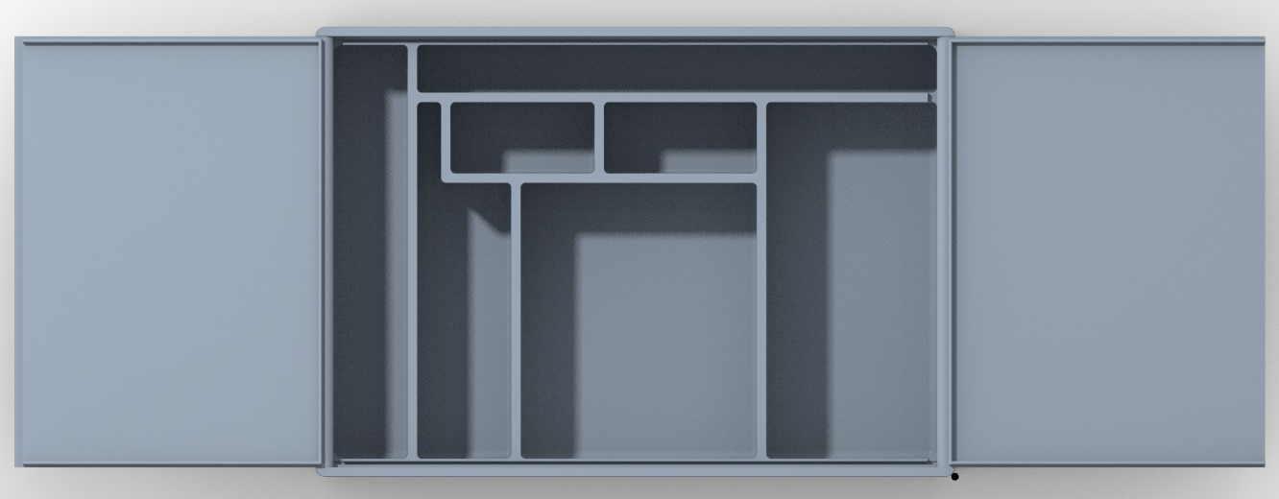

Maintenance
Cleaning
As toiletry cases can become dirty overtime through typical usage, such as residue formed from toothpaste, shaving cream, or gels, it is important to maintain them through periodic cleaning.

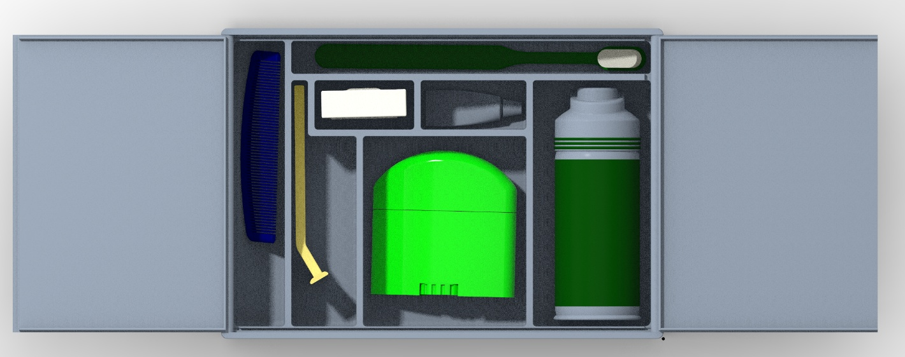
As the product is made entirely of Polypropylene (PP), it is safe to undergo dishwasher conditions like high temperatures and detergent. In addition, the plastic has been treated so users are able to wipe the surfaces with bleach napkins for quick and easy cleaning.

Safety Information

THIS PRODUCT IS NOT A TOY. INJURY MAY OCCUR IF THE PRODUCT IS NOT USED OR HANDLED PROPERLY.

The hinge features of the dual-purpose lids yield the possibility for finger and limbs to become pinched or caught if not handled correctly. Additionally, the individual should be aware when assembling or disassembling the product as the lids fit tightly into their secured locations to prevent moisture from escaping the case.

Warranty Information
The Pocket Toiletry Case™ is backed by a thirty (30) Day Money-Back Guarantee. If you are not 100% satisfied with the product, refer to the contact page to request a refund.
For ninety (90) days after purchase date of The Pocket Toiletry Case™, Travel Pro Inc. will replace any damaged parts for free (just pay shipping and handling). After ninety (90) days of the initial purchase date of The Pocket Toiletry Case™ has passed, the company is no longer responsible or obligated to replace damaged parts. For parts and prices, please refer to the “Service Center” section of this manual.
Travel Pro Inc. is NOT responsible for any damage that may be caused to any portion of the Case during use. Complaints of such nature will be dismissed by our Service Center. Customer assumes risk of product usage.
Modifying or changing the design of The Pocket Toiletry Case™ IN ANY WAY will result in a void in your warranty and will automatically make the operator entirely liable if any malfunction may result.

Service Center
During the printing of this User Manual (2023) the following information is correct. However, please refer to our website for our latest email, phone number, and mailing address.

Company phone line
888-PRO-FLOW

Company mailing address:
9201 University City Blvd, Charlotte, NC, 28223

Jake Kudla
IT/Web designer
jkudla1@uncc.edu
Dustin Phillips
CAD Design
dphill58@uncc.edu
Maxwell Gonzalez
CAD Design
mgonza84@uncc.edu
Zackery Lowell
Legal and Human Relations
zlowell@uncc.edu

